(1) Select a set of data from the database as the database for image classification.
(2) Adjust the image size to 224*224.
(3) Use mylayer1.m as the reference code and use the following neural network architecture. 。
(4) Use Matlab's sample program (Create Simple Deep Learning Neural Network for Classification, detailed in the PPT in Section 2.1), replace its data and network with your own data and network, and perform training and verification.
(5) Train your neural network.
(6) Verify the accuracy of image classification.
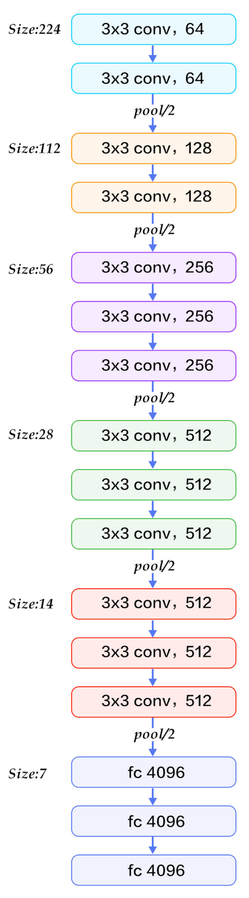
(7) Final report
mylayer1.m
convolution2dLayer(3,128,'Name','conv_1a')
convolution2dLayer(3,128,'Name','conv_1b')
batchNormalizationLayer('Name','BN_1')
reluLayer('Name','relu_1')

maxPooling2dLayer(2,'Stride',2,'Name','pool_1')

layers = [
imageInputLayer([32 32 3],'Name','input')
convolution2dLayer(5,6,'Name','conv_1')
batchNormalizationLayer('Name','BN_1')
reluLayer('Name','relu_1')
maxPooling2dLayer(2,'Stride',2,'Name','pool_1')
convolution2dLayer(5,16,'Name','conv_2')
batchNormalizationLayer('Name','BN_2')
reluLayer('Name','relu_2')
maxPooling2dLayer(2,'Stride',2,'Name','pool_2')
fullyConnectedLayer(400,'Name','fc_3')
fullyConnectedLayer(10,'Name','fc_4')
softmaxLayer('Name','softmax')
classificationLayer('Name','classOutput')];
layer1=layerGraph(layers);
plot(layer1)

